**Art John T. Amaro**

**I102**

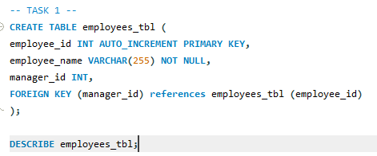**TASK 1. QUERY STATEMENT**

**TASK 1. TABLE STRUCTURE**

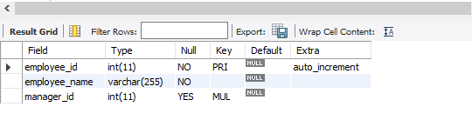

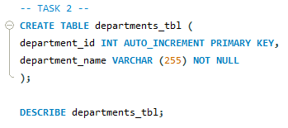**TASK 2. QUERY STATEMENT**

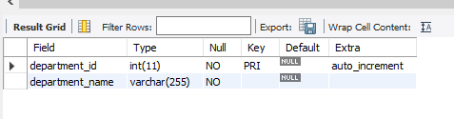**TASK 2. TABLE STRUCTURE**

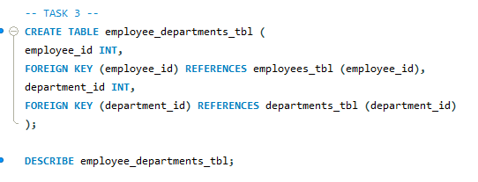**TASK 3. QUERY STATEMENT**

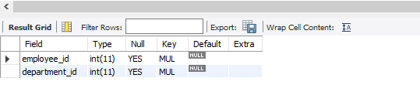**TASK 3. TABLE STRUCTURE**

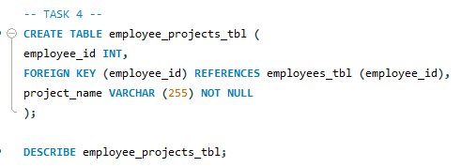**TASK 4. QUERY STATEMENT**

**TASK 4. TABLE STRUCTURE**

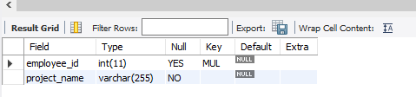

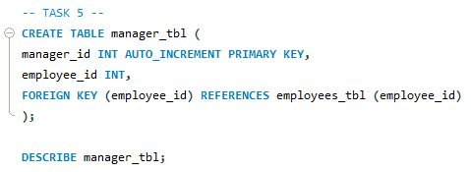**TASK 5. QUERY STATEMENT**

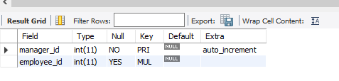**TASK 5. TABLE STRUCTURE**

**EER DIAGRAM**

